TECHNICAL IMPLEMENTATION & ANALYSIS

5.1 OUTLINE
The implementation stage of the software development is the process of converting a system specification into an executable system. Each component of the design is implemented as program modules and each of these program modules are undergoing a unit testing. The end product of this phase is a set of program modules that have been individually tested. It always involves the process of the project design and programming. A software design is the description of the structure of the software to be implemented, the data which is the part of the system, the interfaces between the system components and algorithms used.

This project contains four Modules. Module 1 is about User interaction . The user interaction module handles standard user interaction functionality where we extract product information being requested by the consumer . The purpose of this module is to provide communication services between the clients and cloud provider and start the process to find the relevant information on the product requested. Module 2 describes the Data Gathering , where a query for the product details has been made and the data (prices of the products in this case) is being retrieved from the retailers and stored . Module 3 is described about data processing where the results from the Data Gathering will be filtered and normalized , later the comparison of prices from various retailers will be generated . and lastly Module 4 involves the user interface and interaction where the results of comparison will be displayed and the links to the respective retailer’s link will be provided to the user in order to choose the best option according to his/her preference. The user will be later redirected tp the website of the chosen retailer to buy the product.

5.2 TECHNICAL CODING AND CODE SOLUTION

Front Page of the Website (Login Page)[JS,CSS,HTML5]
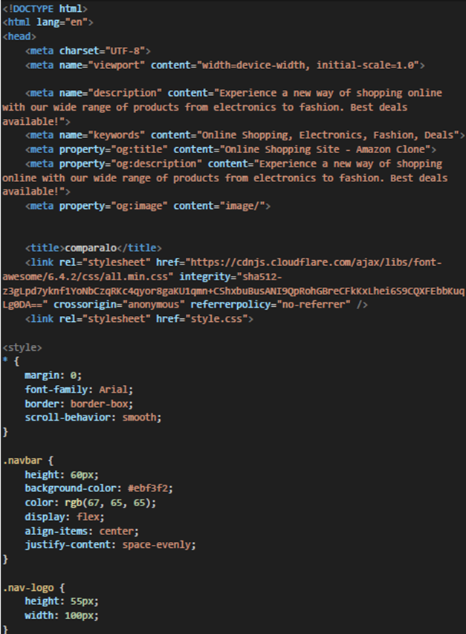

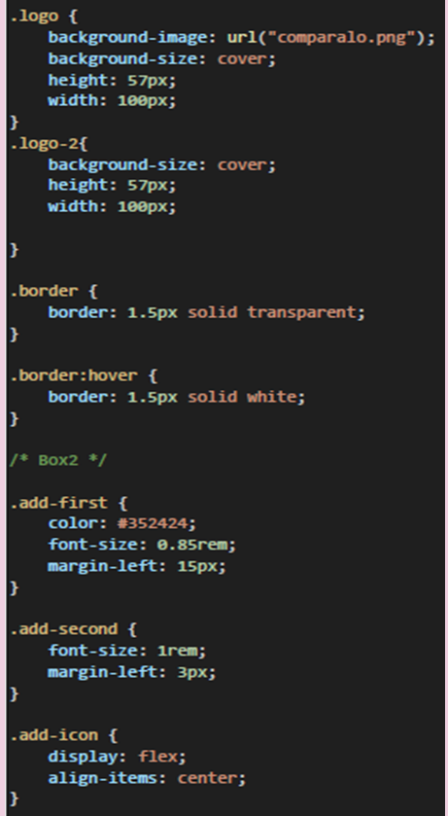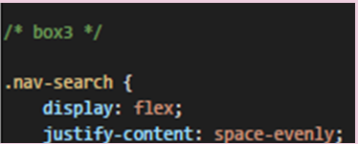

Backend Code (Web Scrapping using API interference of Amazon , Myntra , Flipkart)[Python]

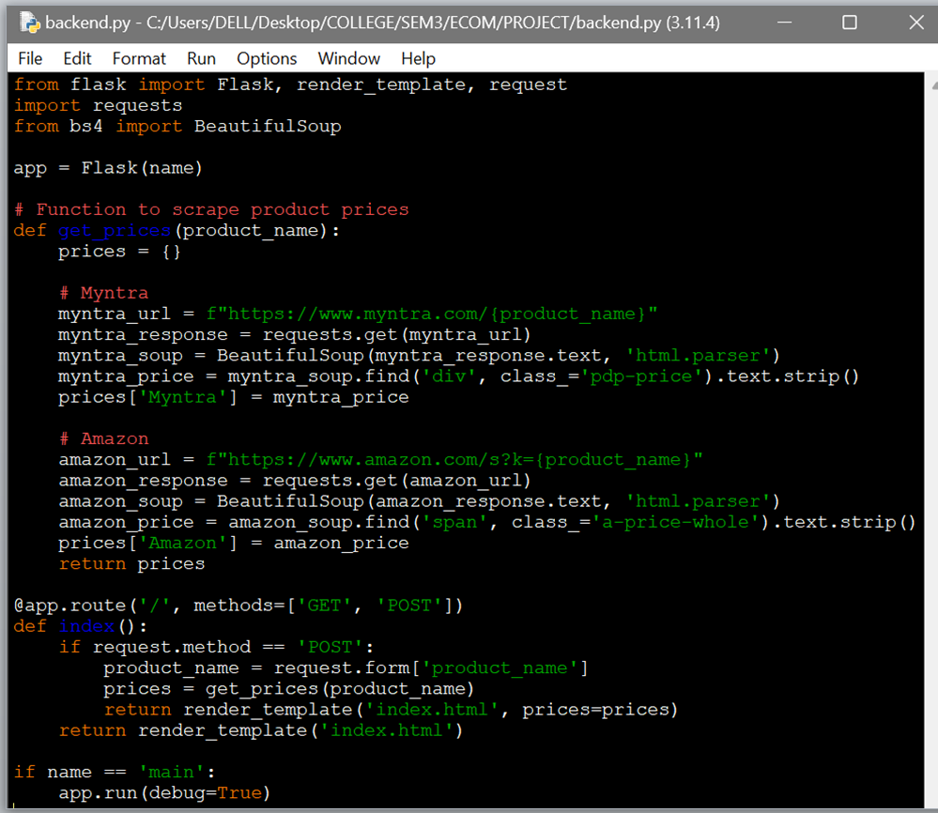

5.3 WORKING LOYOUT OF FORMS

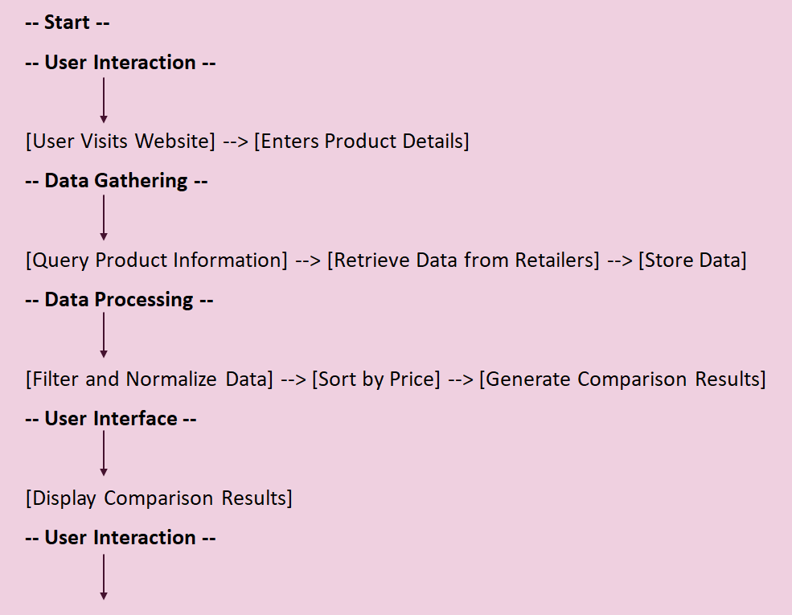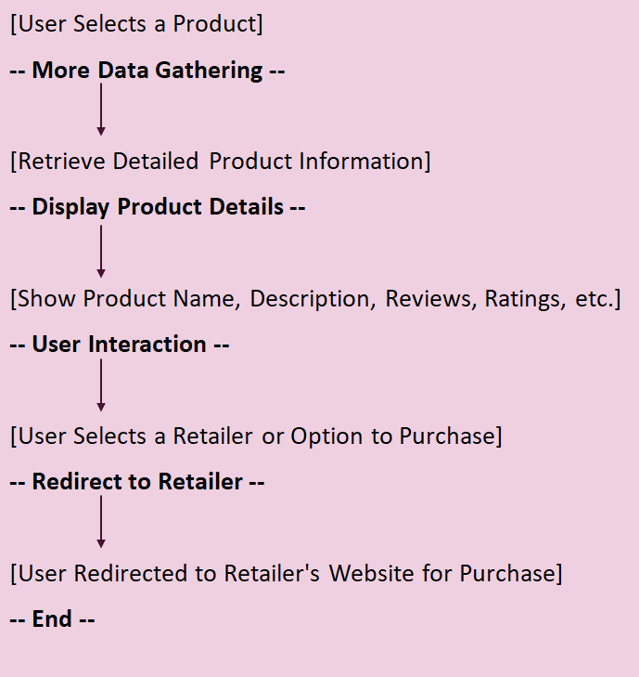

PROTOTYPE:

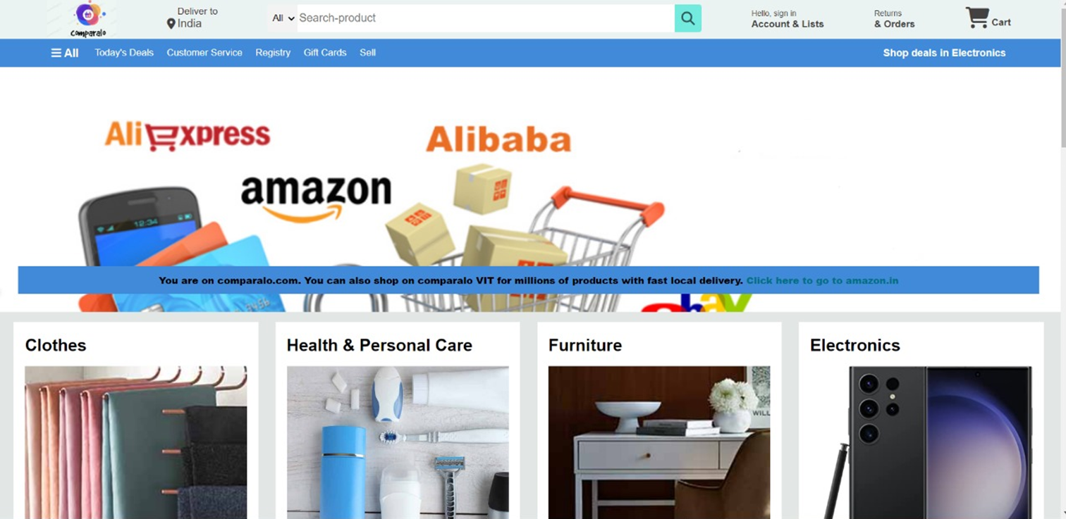
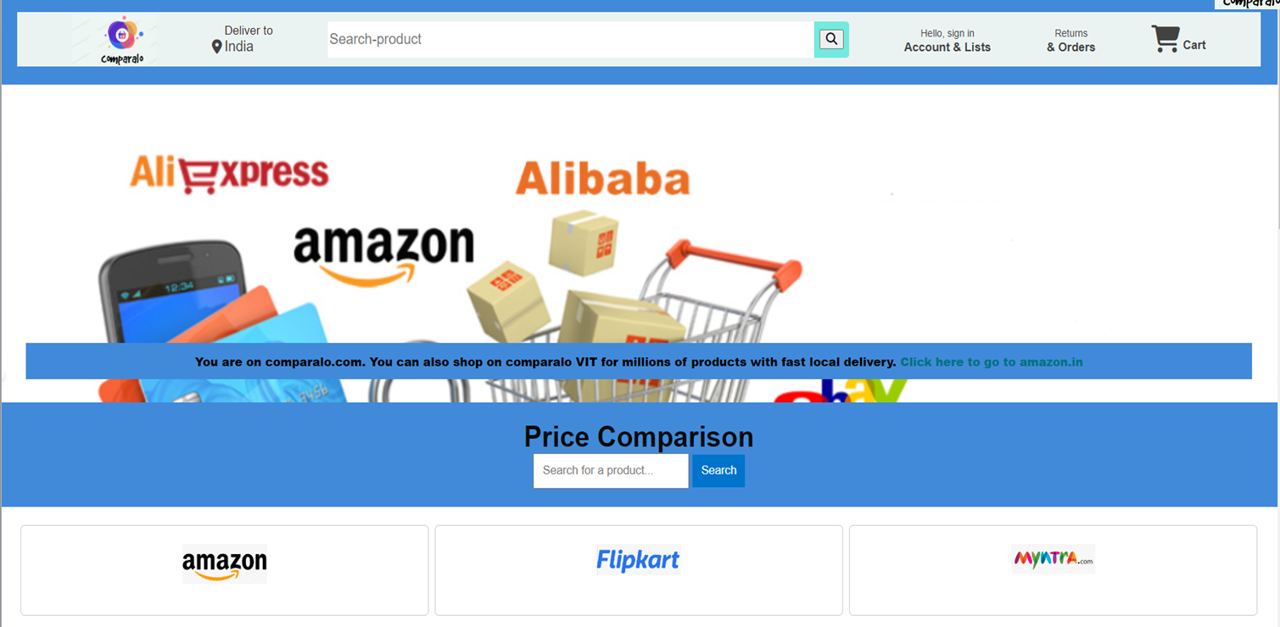
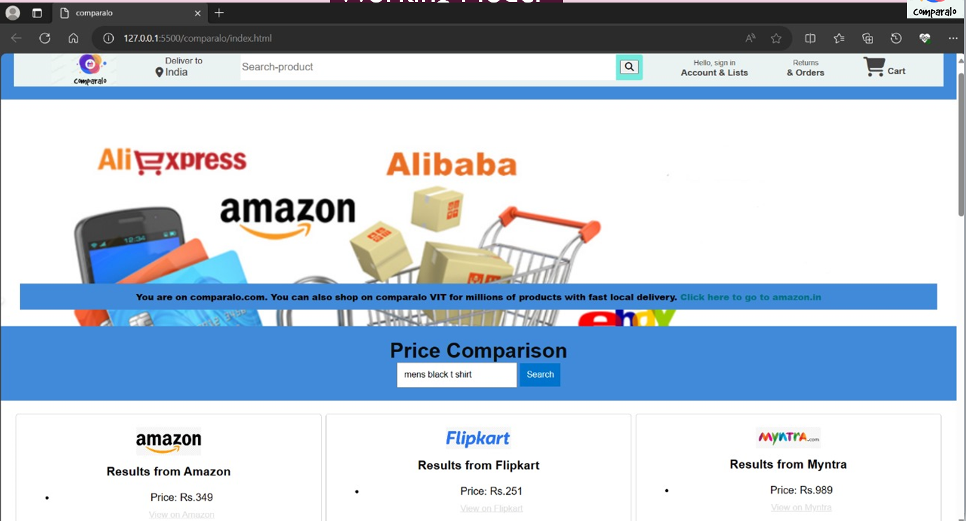

5.5 TEST AND VALIDATION
In this section we are discussing about all the possible test cases of this project. It will include the positive and negative test scenarios. By executing the below test cases can examine the functionality of this project.

5.5.1 LOGIN TEST
Action | Input | Expected Result | Output
Access the URL | Application URL | User should able to open URL | Able to access the URL
Login | Username/E-mail  Password | User should able to login with his E-mail & Password | Welcome Page
Login Failed | Invalid User Name or Password | User won’t able to login to the application | No account found with this email
5.5.3 SEARCHING AND DISPLAYING OF PRICES
Action | Input | Expected Result | Output
Enter product name in Search bar | product Name | The comparison of prices from various websites should be shown | prices Shown in Feed
Search bar | Empty Input | Give a Warning to Enter the Input | Still in Welcome Page
5.5.4 Comparison and redirecting to retailer’s website
Action | Input | Expected Result | Output
Displaying the comparison | Product Name | Price Details of the product given by user is | Price Details
Link to the retailers website | Empty Input | Link to the retailers website | URL to the website

